**Work Flow of Server**

1. Server ( server.js):

* A server is a place, which connects to other libraries and databases.
* The server also exchanges information and data between the database and the client.

1. Routes: ( tuyến đường )

* It represents the API in the server workflow, which can help the server respond to a specific request for a particular request from the client.
* For example: When a client requests for login form through API ( /authentication/form) server will look for a corrected route in Routes to answer for the client.

1. Connector : ( Connect multiple routes to server )

* Look up the correct route

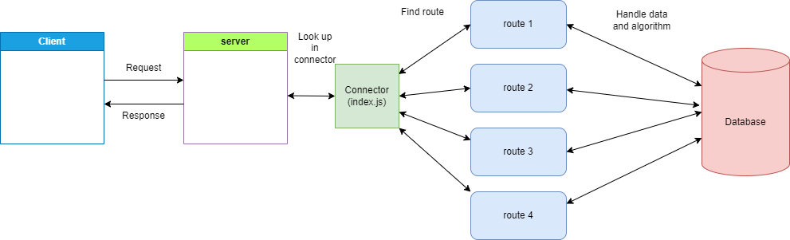

1. Work flow of Backend server:

* This workflow is not the best, we can optimize in the future, which depends on the outcome of the project and the difficulty of algorithms.

